Project Design Phase
Problem-Solution Fit Template
Date | 31 OCTOBER 2025
Team ID | NM2025TMID04230
Project Name | Education Organisation Using ServiceNow
Maximum Marks | 2 Marks

Problem-Solution Fit Template
The core challenge faced by the education organisation lies in a fragmented service experience for both students and staff. Students, like Alex, whose primary goal is to focus on academics, are burdened by having to navigate multiple legacy portals (for IT, Registrar, Bursar, etc.) to complete a single task, resulting in wasted time and missed deadlines. Simultaneously, Administrative Staff, such as Sarah, are trapped in inefficient, manual processes—tracking requests through email and spreadsheets, which causes slow resolution times and a complete lack of visibility for leadership into service delivery performance. The ServiceNow implementation provides a direct solution to these pains. It offers a Unified Portal (via the Service Catalog and Customer Service Management) that acts as a single, intuitive gateway for every service request, delivering a seamless, mobile-friendly experience to the student. For staff, the platform implements Automated Workflows (leveraging ITSM/HRSD) to instantly route and track requests, drastically reducing manual effort and driving a significant increase in efficiency. Furthermore, ServiceNow's Performance Analytics capabilities solve the organizational visibility problem by providing real-time dashboards on workload and bottlenecks. Success will be validated by measurable improvements: a jump in Student Satisfaction (CSAT) to over 80%, a decrease in Request Resolution Time from days to hours, and a high Service Inquiry Deflection Rate (e.g., 30%) due to effective self-service knowledge. This validated fit confirms the ServiceNow project directly addresses the most critical service delivery issues facing the organization.
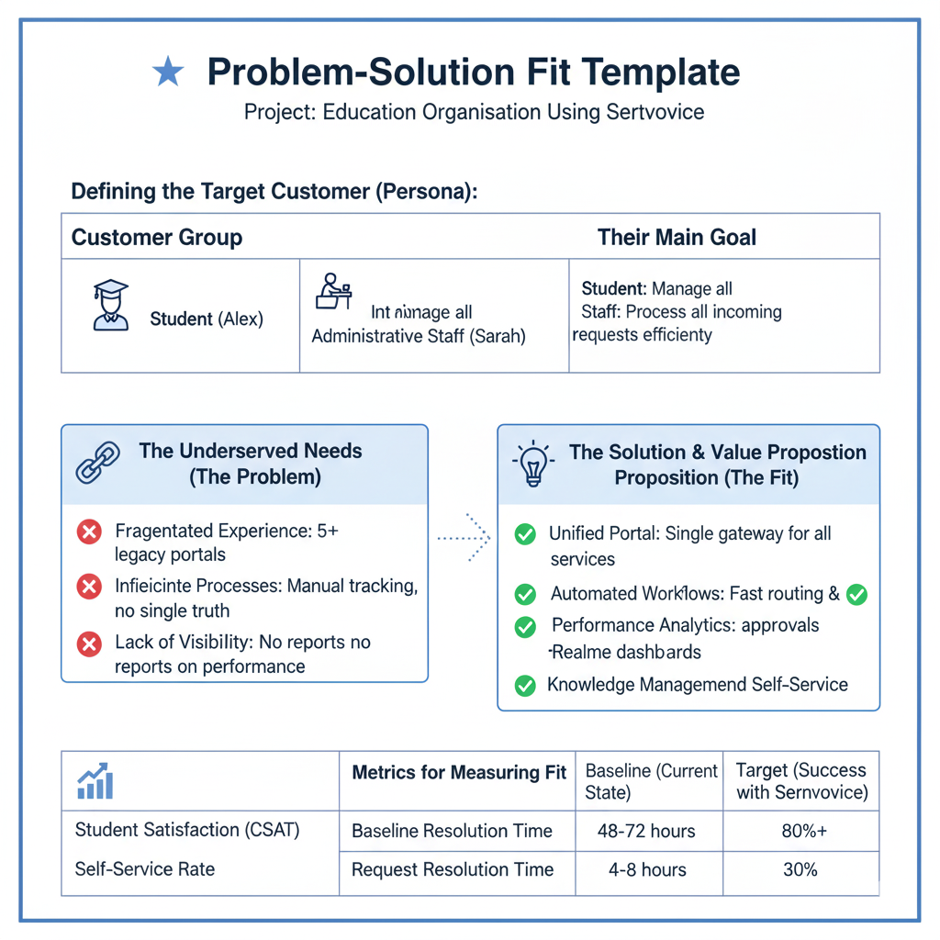
The core problem addressed by the ServiceNow project is the fragmented service experience for the organization's users. For the primary persona, Alex the Student, the current pain is a Fragmented Experience, forcing them to jump between multiple legacy portals for a single task, resulting in slow resolution times and wasted effort. The proposed solution on the ServiceNow platform directly solves this with a Unified Portal and Automated Workflows. This provides a Single Point of Entry for all services, ensuring transparency and speed in handling requests. For the Administrative Staff, the pain is Inefficient Processes—a heavy reliance on manual tracking via emails and spreadsheets—which is solved by ServiceNow's automated routing and approvals, leading to significant Increased Efficiency. Success for the project will be measured by a high Student Satisfaction (CSAT) score, a dramatic reduction in Request Resolution Time, and a substantial 30% deflection of routine inquiries through the new self-service knowledge base and virtual agent. The ultimate value delivered is a cohesive, modern, and data-driven service ecosystem for the entire campus community.
